**About the data**

K-Mart, a departmental store that operates in 4 regions in the United States (Midwest, South, Northeast, West) sales records.

Number of records

20,000

**Definition of terms**

* Revenue – Total amount of money made by the business in each period
* Unit Cost – The cost incurred by the business to produce a unit of a product
* Unit Price - The price a unit of a product is being sold at
* Product Category – The group certain products can be classified as

**Business Questions:**

* What are the top three best-selling product categories in all 4 regions?
* What product category should we increase or decrease its stocks for all regions
* What increases the revenue?
* What salesperson deserves a promotion or demotion?

**North Star Metrics**

* Revenue by product category
* Stock of product category
* Key indicators of revenue growth
* Revenue by Salesperson

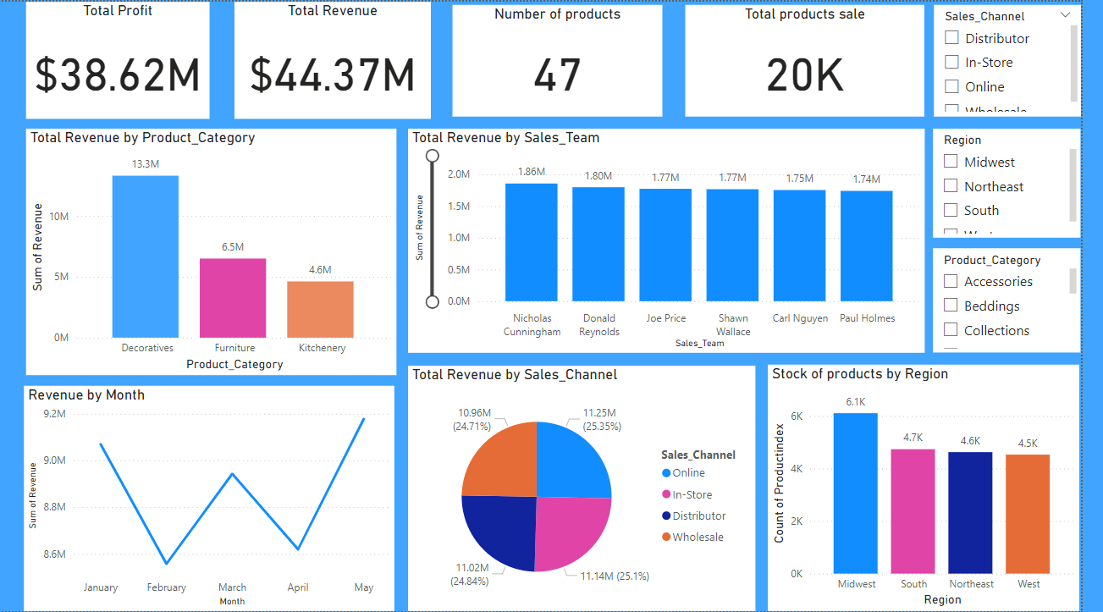

Observations:

* Total revenue generated for the period is $44.37 million
* Total profit generated for the period is $38.62 million
* The total number of unique products available at each store’s location is 47
* The total number of products sold is 20k
* The most revenue is generated by Online sales channel
* Midwest has the highest number of product stocks at over 6k
* Nicholas Cummingham generated the most amount of revenue, at 1.8 million.

Insights

**Product Category:**

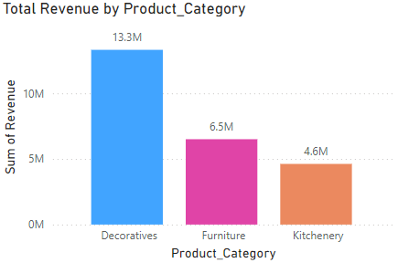

* Decoratives, Furniture and Kitchenery are the top three product categories with the highest revenue. Consequentially, they are also the top three categories with the highest unit cost. At face value, we can draw inference that a product with a high unit cost will also generate a high revenue. Furthermore, a high unit cost can be theoretically attributed to a high-quality product, such we can deduce that a high-quality product will generate high revenue.

**Product stocks Increase or decrease:**

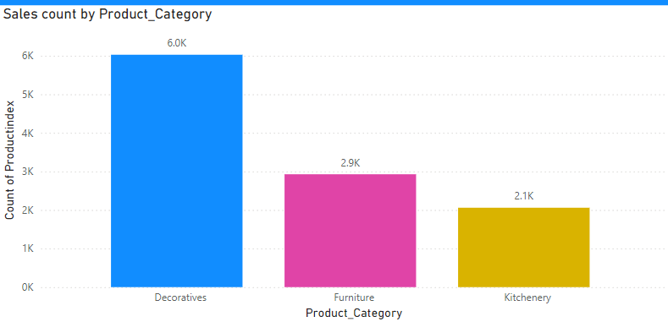

* The Top 3 products that should be increased in stocks are Decoratives, Furniture and Kitchenery. Decoratives have had a total of 6,026 sales across all regions (the highest demand), followed by Furniture at 2927 and Kitchenery 2059. These three categories represent the products categories with the highest demand, and stocks of these three categories should be increased across all regions.

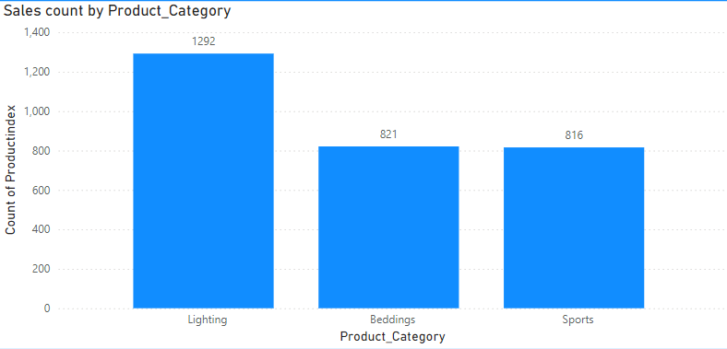On the other hand, Lighting at 1292 product sales, Beddings at 821 and Sports 816 have the lowest demand across all regions and stocks of these can be reduced to improve profit margins.

**Revenue:**

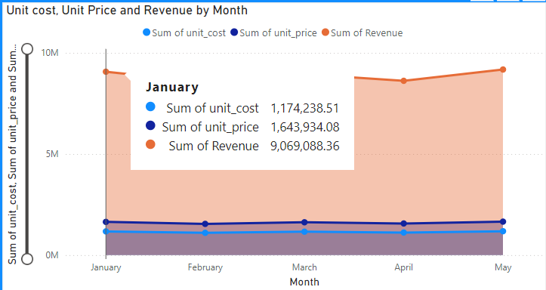

* Revenue is highly impacted and driven by the unit cost and unit price of a product category. The data describes a pattern between these three data points. The higher the unit cost, the higher the unit price and the higher the revenue. So, we can infer that a high unit cost means a high-quality product and correspondingly, people are willing to pay more for a quality product, hence a high unit price. This ultimately leads to high revenue and vice versa if the unit cost and price are low.

**Salesperson deserving a promotion or demotion:**

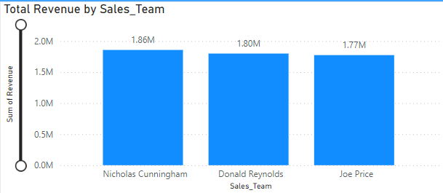

To determine a Salesperson that deserves a promotion or demotion, the revenue generated by each salesperson will be considered. The top 3 salespeople with the highest revenue should be promoted and the bottom 3 should be demoted. The salespeople in the middle can be placed on a performance improvement plan. From the data, we can see that **Nicholas Cunningham, Donald Reynolds and Joe Price** are the **top three** salespeople by revenue and should be promoted while **Jerry Green, Stephen Payne and Douglas Tucker** are the **bottom three** salespeople and should be demoted.

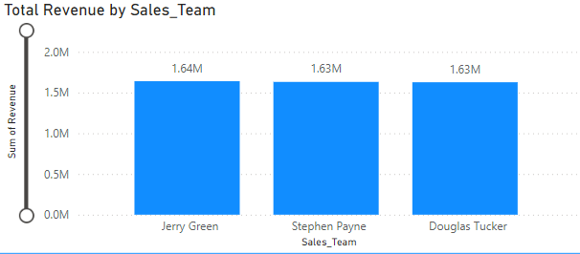

**Recommendations:**

**Products:**

* Product needs to ensure that the quality of the product categories is top-notch by not undercutting on unit cost as the data suggests that products with a high unit cost and price generate the highest revenue and customers are willing to spend more on them.
* Product needs to find low-margin areas e.g. Cut costs of underperforming product categories like Lighting, Beddings and Sports to increase profit.

**Inventory management:**

* It is important to keep a good stock of the product categories (Decoratives, Furniture and Kitchenery) that are in demand and reduce the stock of the ones (Lighting, Beddings and Sports) that aren’t to reduce costs incurred by the business across all four regions.

**Management:**

* Management needs to make some tough decisions in letting go or creating a performance improvement plan for the bottom 3 underperforming salespeople and rewarding the top 3 best performing salespeople to promote competency within the business.